

HUMAN RESOURCES DEPARTMENT

JOB DESCRIPTION

To be completed comprehensively by the job holder.

IDENTIFICATION (full name and staff number, date of employment)

Full Name:

Staff Number:

Date of employment:

1.1 | job title  Job grade  reporting to | Programme Monitoring Evaluation and Research Officer  TBD  NTD Programme Manager
1.2 | department/program/project | WASH & NTD
1.3 | physical location | Amref Health Africa in Kenya, Wilson Airport, Lang’ata Road

MAIN PURPOSE OF JOB: -

To provide technical support in setting up and managing functional monitoring, Evaluation and Research systems within Amref Health Africa programmes in coordination with various stakeholders

REPORTING RELATIONSHIPS (supervisor and Reportees)

Organogram

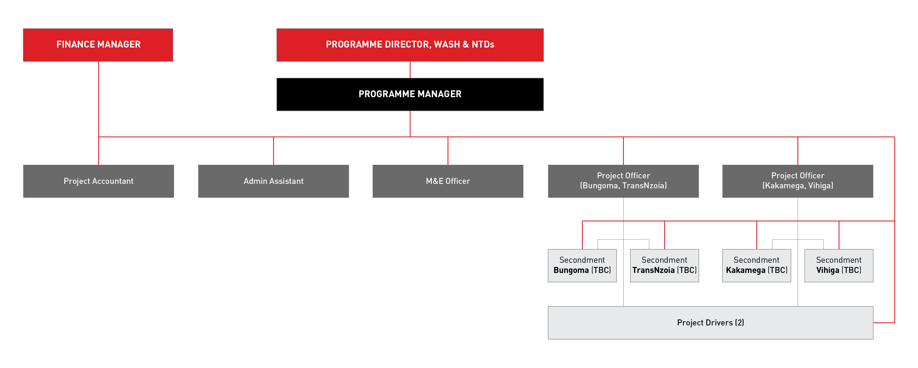

Key
Operational Support
Technical and Administrative reporting
Technical reporting

PERSONNEL

personnel reporting to the job holder (if any)  (not their names but their titles) | reporting directly
Project Monitoring, Evaluation and Research Officers | Direct Technical and Administrative reporting
Monitoring, Evaluation and Research Assistants | Direct Technical and Administrative reporting
Data clerks | Indirect Technical and Administrative reporting

OTHER RESOURCES under your responsibility (equipment and assets)
(e.g. files computers, printers, modem, vehicle etc)

- All furniture and equipment in the WASH& NTD Programme and MER unit
- Computer
- Modem

PRINCIPAL RESPONSIBILITIES
(List all your areas of responsibilities and write down the activities involved in each key area)
KEY AREA | Activities | EXTENT OF DISCRETION (full, partial or none)
Development of MER systems | Support in development and strengthening of MER systems at programme level | Full
Development of MER systems | Provide technical support to projects within a programme during designing of M&E frameworks, plans and Tools | Full
Development of MER systems | Participate in development and implementation of standard operating procedures to guide MER activities | Partial
Development of MER systems | Facilitate review of programme progress on a quarterly basis and ensure problem solving through remedial actions | Full
Development of MER systems | Support in strengthening existing MER systems at Amref Health Africa in Kenya Office | Partial
Capacity Building, Mentorship and Technical Assistance in MER | Support in capacity building of staff in MER through organizing of workshops in various areas; take part in brownbag sessions for sharing of research findings and proposals | Partial
 | Conduct regular field monitoring/mentorship visits to support implementation of MER systems and CQI | Full
 | Provide technical research support in writing of research protocols, ethics approvals, research abstracts and manuscripts | Full
 | Support staff with publication of papers in peer reviewed journals | Full
 | Provide mentorship of program staff in the analysis, interpretation and use of program M&E data | Full
Business Growth | Support in development of proposals within the organization | Partial
Business Growth | Support staff in designing and execution of research studies | Partial
Monitoring, Evaluations and Research | Take lead in Data Quality Assessments/Audits at program level | Full
Monitoring, Evaluations and Research | Lead evaluations both conducted internally and by consultants | Full
Monitoring, Evaluations and Research | Provide guidance in reporting within the programme and quality assure donor reports | Full
Monitoring, Evaluations and Research | Secretariat to Amref Ethics and Scientific Review Committee | Full
Monitoring, Evaluations and Research | Publish at least one paper as lead author in peer reviewed journals | Full
Monitoring, Evaluations and Research | Present at least one paper in local/international conferences | Full
Other | Undertake other relevant duties assigned by the supervisor

6 ANY OTHER TASKS
(E.g. Sitting in various committees)

- Member Continuous Quality Improvement Sub-committee
7 REQUIRED QUALIFICATIONS

7.1 Education (academic and professional as per Amref Health Africa in Kenya not what you hold)

- Minimum of a bachelor’s degree in Public Health, Statistics, social sciences or other related discipline.
- Master’s degree desirable
- Professional Training in research methods, monitoring and evaluation

  - Experience (number of years as per Amref Health Africa in Kenya)

- Experience in monitoring and evaluation, operations research and health programs design
- At least 5 years of experience in M&E, biostatistics in health-related field

7.3 Skills

- Good communication and interpersonal skills
- Good analytical skills
- Practical computer skills
- Strong team work skills

7.4 Competences

- Strong data management and analysis skills
- Expert knowledge of data analysis programs such as SPSS, STATA, and/or EPI INFO
- Experience working with GOK, health programs and conversant with M&E systems in Kenya
- Performance management and Project quality improvement
- Developing M&E system (include M&E plan and Frameworks)

- ENVIRONMENTAL CONDITIONS

8.1 Corporate Policies, Systems, Procedures and Methods

- As per HR policy and procedures

8.2 Work Environment

- Around 60% of the Job holder’s time is spent in the office while 40% spent in the field at project level.

8.3 Hours of Work
- As per HR policy and regulations
- Occasionally the job holder’s work necessitates that s/he works during weekends to meet work deadlines

ACKNOWLEDGEMENT AND APPROVAL
We have carefully reviewed this Job Description and we are both satisfied that it fully and
accurately describes the requirements of the position

Immediate supervisor

Signature: ______________________________________________________

Date: ____________________________________________________________

I have read this document and agree to undertake the duties and responsibilities as listed
above. I also acknowledge that this description of tasks is only indicative and that it is my Responsibility to be an active and supportive member of the team. Therefore, I may be required to undertake additional duties and responsibilities from time to time that are not detailed herein.

However, if the new tasks constitute a substantial change of the duties and responsibilities listed above, the supervisor and the job holder can at any time request renegotiation of the job description (for changes to be considered substantial, they should amount to at least 15% of the total working hours).

JOB HOLDER

Name: ____________________________________________________________

Signature: ________________________________________

Date: _____________________________________________

HR Department
APPROVED and FILED in Staff file

Received, approved and filed.

Names and Signature

